# SCHEDULE VISTARA PROJECT

A PROJECT REPORT

*Submitted by*

|  |  |  |  |
| --- | --- | --- | --- |
| **Roll Number** | **Registration Number** | **Student Code** | **Student Name** |
| **21010201038** | **21012003036** | **BWU/MCA/21/038** | **Akash Rakshit** |
| **21010201046** | **21012003046** | **BWU/MCA/21/048** | **Abir Samanta** |
| **21010201047** | **21012003047** | **BWU/MCA/21/049** | **Debajyoti Bar** |
| **21010201102** | **21012003058** | **BWU/MCA/21/060** | **Subhadip Kowar** |
| **21010201039** | **21012003037** | **BWU/MCA/21/039** | **Sujay Kumar Mondal** |

*in partial fulfillment for the award of the degree of*

**Masters in Computer Application**



### Department of Computational Sciences

**BRAINWARE UNIVERSITY**

### 398, Ramkrishnapur Road, Barasat, North 24 Parganas, Kolkata - 700 125

June, 2023

# SCHEDULE VISTARA

***Submitted by***

|  |  |  |  |
| --- | --- | --- | --- |
| **Roll Number** | **Registration Number** | **Student Code** | **Student Name** |
| 21010201038 | 21012003036 | BWU/MCA/21/038 | Akash Rakshit |
| 21010201046 | 21012003046 | BWU/MCA/21/048 | Abir Samanta |
| 21010201047 | 21012003047 | BWU/MCA/21/049 | Debajyoti Bar |
| 21010201102 | 21012003058 | BWU/MCA/21/060 | Subhadip Kowar |
| 21010201039 | 21012003037 | BWU/MCA/21/039 | Sujay Kumar Mondal |

***in partial fulfillment for the award of the degree***

***of***

**Masters in Computer Application**

***in***

### [Department of Computational Sciences]



**BRAINWARE UNIVERSITY**

*398, Ramkrishnapur Road, Barasat, North 24 Parganas, Kolkata - 700 125*



**BRAINWARE UNIVERSITY**

*398, Ramkrishnapur Road, Barasat, North 24 Parganas, Kolkata - 700 125*

### [Department of Computational Sciences] BONAFIDE CERTIFICATE

Certified that this project report “**SCHEDULING SYSTEM**” is the bonafide work of “**AKASH RAKSHIT, ABIR SAMANTA, DEBAJYOTI BAR, SUBHADIP KOWAR, SUJAY KUMAR MONDAL** ” who carried out

the

project work under my supervision.

**SIGNATURE SIGNATURE**

DR. Jayanta Aich Ms. Shrabani Sutradhar

**HEAD OF THE DEPARTMENT SUPERVISOR**

ASSISTANT PROFESSOR

Department of Computational Sciences Department of Computational Sciences Brainware University

398, Ramkrishnapur Road, Near Jagadighata Market, Barasat, North 24 parganas, Kolkata, West Bengal - 700 125

**External Examiner**

|  |  |  |
| --- | --- | --- |
|  | **TABLE OF CONTENTS** |  |
| **Chapter** | **Title** | **Page No.** |
| **1.** | 1. **ABSTRACT**    1. **INTRODUCTION** | **2-5** |
| . | **1.2 LIST OF TABLE** |  |

**1.3 LIST OF SYMBOLS**

1. **2. LITERATURE REVIEW**
   1. Content analysis
   2. Taxonomic analysis
   3. Thematic analysis
      1. Trend 1

**6-9**

1. **3. BACKGROUND 9-13**
2. **4. DATABASE METHODOLOGIES**

**AND CONTRIBUTION**

* 1. SYSTEM IMPLEMENTATION AND VALIDATION
  2. Class Schedule Option
  3. CONCLUSION AND FUTURE WORK

1. **5. REFERENCES**

**13-28**

**29**

1. **ABSTRACT**

Abstract—Schedule Vistara is a software that improves these processes. The system has features that can provide a database for storing records and information. It allows the end-user to add, edit, delete, save and update records or information if some changes occur. It can generate reports for example class schedule, class list, instructors list, hall list, department list and school year with different semesters. Schedule Vistara is a Class management system for a university for handling the course studying in which semester, managing user profiles and allowing authority for users to let them retrieve and export information of course details. It is a better solution with many flexible and convenient features, allowing class administrators and instructors to maximize efficiency while reducing time wastage. In this paper a Schedule Vistara is designed and developed as a web database application system by PHP language with MySQL database management system. Finally, it takes a few minutes to come up with complete high-quality solution for assigning a significant improvement over of manual work. The most effective point for this system that has a flexibility and scalability which is very important for the future you can do more development on it. Schedule Vistara needs some future work and correlations. Design and implementation of smartphone application is remained as a future work. Users can

access to the application anytime and in anywhere with smartphone application, even though they don’t have access to desktop applications.

Keywords, Database, Schedule Vistara, MySQL, PHP, Apache

# INTRODUCTION: -

Now a days the technology has grown very fast, it has a big impact on our daily lives. Using it goes toward the advantage in learning field and very effective. However, database is the organized gathering data, it is making the relationship between tables and a collection of schemas, tables, views, queries and reports [1]. The class schedule project is a game oriented medium where questions are distributed rely on the response’s knowledge levels and very helpful orientations are provided.

Creating

such platforms very helpful for instructors to search the subjects, students that have this class, semester, and the length of the class per week.

Class schedule management system provides the accessibility for admin and instructors to use it in simplest way to determine their data, it connects the relational table together such as (Class table, instructor table, time table, class table and etc.).

Then the users can export the required reports for any queries that they need it. A scalability of this project is most important role to expand it by requesting more new ideas and thoughts. Finally, the simple and friendly system will make the flexibility to use different level of understanding knowledge of users.

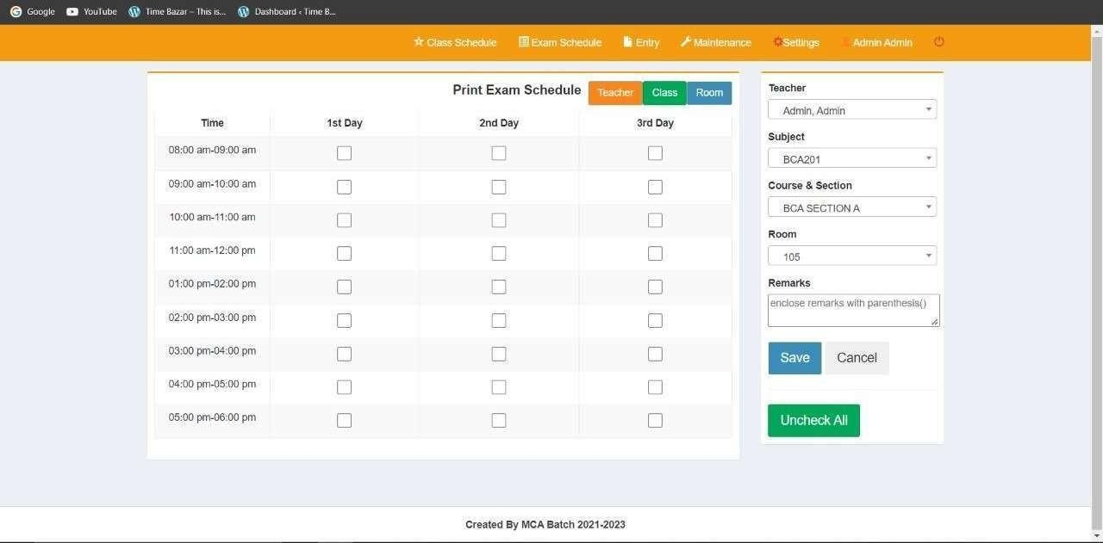

*Fig 1:-Exam Schedule Page*

# LIST OF TABLES: -

1. CYS (Class Year Section)
2. DEPT (Department)
3. DESIGNATION
4. EXAM_SCHED
5. MEMBER (Faculty)
6. PROGRAM
7. RANK
8. ROOM
9. SALUT (Title used before a surname)
10. SCHEDULE (For class)
11. SETTINGS (Active Year)
12. SIGNATORIES
13. SUBJECT
14. SY (Session Year)
15. TIME
16. USER

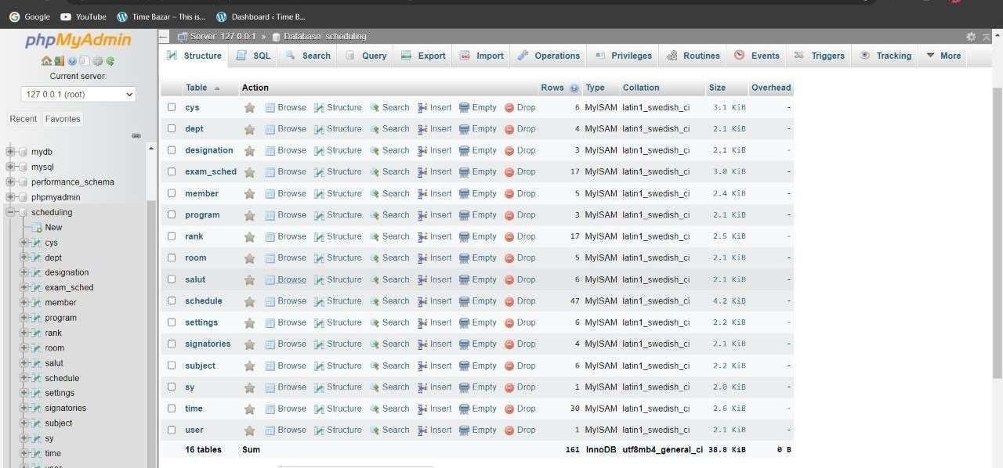

*Fig 2:- Tables in scheduling database*

# LIST OF SYMBOLS: -

1. Check Box
2. Massage Icon
3. Lock Icon
4. Setting Icon
5. Star Icon
6. Admin Icon
7. People Icon
8. Document Icon



*Fig 3: - Using Symbols*

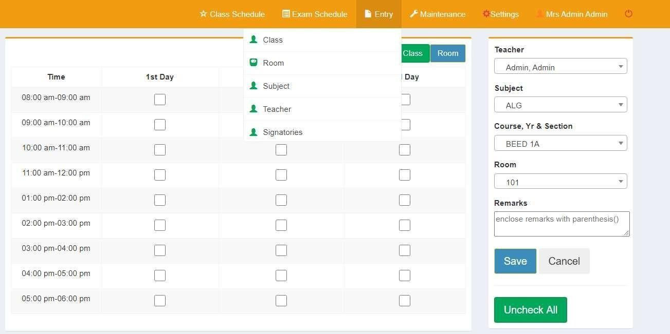

*Fig 4: - Data Entry Page*

# LITERATURE REVIEW

Schedule Vistara is a common problem faced in various organizations and is the most important issue every University has to solve. It is one of the computationally difficult problems in scheduling the exams without conflicts. Scheduling problems can arise in different situations, but most of the times it is referred to scheduling of exams in educational institutions. In fact, examination-class timetable is an important area to be studied and a number of researches have been developed in this area. Many novel researches that focused on modeling and formulating exam-class timetable problems are studied and analyzed in this study. Depending on the nature of the scheduling problem, the objective may vary from one research to another to find the most feasible solution that can cope with a specific environment. This literature survey focuses on examining the major solution approaches for the timetabling problem and compare them, in order to provide directions for academicians and researchers for further work. Keywords- Scheduling System, Scheduling, Exam- class Timetable.

* 1. Content analysis

The first step of the content and taxonomic analysis of the literature review, generally, consisted of:

-

Identifying the research methodology, i.e. (C) conceptual, (D) descriptive, (E) empirical, (ECS) exploratory cross-sectional and (EL) exploratory longitudinal.

-

Indicating the industrial sector in which research was conducted.

-

Classifying the documents based on the conceptual schemes used within the framework of this research, i.e. (DT-ZDM-S) the DT-enabling ZDM-based scheduling, (DT-S) DT-enabling scheduling, (ZDM-S) ZDM-based scheduling and

(O) other relevant schemes.

-

Detailing the objective of the document.

-

Detailing experiments or case studies, if any.

-

Detailing the main contributions and limitations of the reviewed literature.

Appendix E presents the results of this first content analysis and the following figures are worth noting: (i) The majority of the research methodology is experimental, with 53 of 68 (78 %), which indicates that most of the reviewed documents contained research results in an advanced stage and were, therefore, empirically validated; (ii) exploratory research methodologies were not a trend (only 1), which could be related to the fact that DT technology continues to be a topic that is addressed by more academics than companies, and is still far from being widely used in business practice. This situation also occurs, albeit on a smaller scale, with the ZDM management model; (iii) 90 % of the documents (61 documents) were cross-sectoral nature. This lack of [sectoral](https://www.sciencedirect.com/topics/engineering/sectoral)

specialisation in the research indicates, once again, that it is a scarcely addressed framework in the business sphere; (iv) as regards the conceptual frameworks with which the documents in the literature reviewed were aligned, six corresponded to the DT-ZDM-S framework, 37 to the DT-S partial framework, eight to the ZDM-S partial framework and 17 derive from these frameworks (framework O), but maintain some relevance for the framework. It should be noted that five of the DT-S and ZDM-S papers provided additional schemes that could also be classified as O-schemes, which were identified as DT-S/O and ZDM-S/O. It can be deduced that the authors’ tendency to investigate solutions for scheduling issues based on DT technology was more pronounced than their study of scheduling in [ZDM environments](https://www.sciencedirect.com/topics/engineering/design-and-environment), but the latter tendency was not negligible as several authors opted for this research line. Contributions to the ZDM-DT-S framework were still only a few in terms of number of publications, but the five papers addressing involved three authors and were published in 2020 and 2021. These details indicate that this is a recent topic still to be explored. It is worth highlighting publication which, despite not being included in the literature review for being a doctoral thesis, addresses the ZDM-DT-S approach. It focused on quality control and the four ZDM strategies (i.e. detection, prediction, prevention, repair), and the DT, which replicates the scheduling process and is used to: firstly investigate the possible ZDM alternatives available among these three strategies; to secondly conclude which quality control configuration was the most suitable.

The analysis of the DT technology in the reviewed documents is set out in Appendix G and consists of the following:

-

Detailing the role played by the DT.

-

Specifying the physical and virtual entities in the DT.

-

Identifying the basic purpose of the virtual process; i.e. (OP) optimisation, (S) simulation, (P) prediction, (A) analysis, (MPI) multiphysics integration, and (O) others.

-

Determining the level of integration of twins into [virtualisation](https://www.sciencedirect.com/topics/engineering/virtualization); i.e. (DM) digital model: with no data exchange between physical and virtual entities; (DS) digital shadow, with an automated one-way data flow from the physical entity to the virtual one; the DT, with the data flow between the entities fully integrated in both directions.

-

Identifying the main virtually replicated parameter sets; i.e. (S) state: usage, completeness, processes, etc., (L&F) location and shape: dimensions, size, tolerances, position, etc., (F) functionality: functional capability, machine parameters, control, energy, etc., (H) health: monitoring, analysis, management, etc., (T) time: timeliness, exposure, idle and working time, etc., (P&P) process and performance: scheduling parameters, models, defective, etc, (H) health: monitoring, analysis, management, etc., (T) time: timeliness, exposure, idle and working time, etc., (P&P) process and performance: scheduling parameters, models, defective parts or products, etc., (E) environment, (M) miscellany.

-

Identifying the main enabling technologies that integrate DT design; i.e., (BD) big

data, (DM) data mining, (S) sensing, (IoT) [Internet of Things](https://www.sciencedirect.com/topics/engineering/internet-of-things), (CC) cloud computing, (SM) simulation, ML, (AR) [augmented reality](https://www.sciencedirect.com/topics/engineering/augmented-reality), (AM) [additive](https://www.sciencedirect.com/topics/engineering/additive-manufacturing) [manufacturing](https://www.sciencedirect.com/topics/engineering/additive-manufacturing), and (PHM) prognostic and health management.

-

Identifying the implementation software.

From the analysis of DT technology, it is worth noting that: (i) 61 of the 68 papers in the literature reviewed address DT technology; (ii) the basic purpose of the virtual process was mainly multiple and with a tendency to group most designated basic purposes, where the most repeated combination was that integrating optimisation, simulation, prediction and analysis, which was present, on its own or combined with multiphysics integration or other purposes, in 26 out of the 61 papers that addressed DT technology;

(iii) the most frequently addressed basic purpose was S (52), followed by A (46) and OP (45); the least frequent was P (33), with MPI (13) and O (13) being rare; (iv) regarding the data flow integration level, the general interest in the literature lay in the DT (46),

i.e. the technology enabling data flow between the physical entity and its virtual counterpart in both directions; DS (7), which involved data flow only from the physical entity to the virtual counterpart; and DM (2), with no data exchange, which were scarcely studied; (v) as the scheduling process was mostly addressed, the most frequent parameters replicated in the DT were those of the P&P (40), T (36) and S (34) groups; (vi) of the explored enabling technologies, the most frequently present were SM (51), S (31), [IoT](https://www.sciencedirect.com/topics/engineering/iot) (24), BD (21), ML (20) and CC (18). Finally, with significantly fewer occurrences we found other more specific technologies like DM (12), PHM (12), AR (9) and, finally, AM (2); (vii) almost half the documents (32) did not specify the software tools employed to implement the DT. Of those that did, diversity is very high with none standing out. For more detailed aspects of the analysis, readers are referred to Appendix G.

* 1. Taxonomic analysis

Indeed there are three main technological trends revealed by the analysis of the literature review based on the approach adopted to align with SMS: (i) approaches whose alignment with SMS lies in applying DT technology and/or the ZDM management model; (ii) approaches whose alignment with SMS is highlighted by the application of one of the main enabling digital technologies; (iii) approaches whose alignment stems from providing scheduling systems with capabilities inherent to SMS. Additionally, these three methodological trends were divided into 13 alignment axes with SMS, which show that the main implementations of the reviewed literature for scheduling assisted by DT technology and the ZDM management model are characterised by automatic and autonomous management, and synchronised in real time with the physical workshop processes.

* 1. Thematic analysis

Based on the keywords of the reviewed research articles, a map of co-occurring topics was drawn up using the VOSviewer v.1.6.16 tool, where the concepts present in the literature review with more than five occurrences can be viewed, as well as their dimension and interrelations

* + 1. Trend 1: applying the DT technology and/or the ZDM management model

The taxonomic analysis of the reviewed literature that aligns with SMS through the application of the DT and/or ZDM shows three different alignment axes with SMS: (i) fully coincident with the DT-ZDM-S scheme; (ii) with the support of scheduling systems based on DT technology; (iii) with the support of scheduling systems on the ZDM management model.

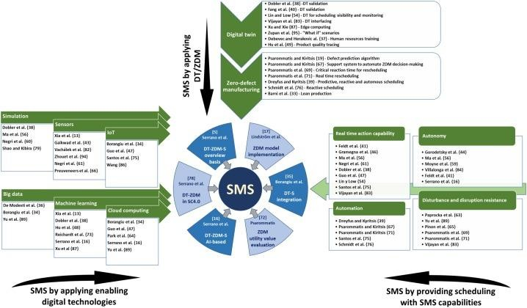

These SMS methodological trends and alignment axes make up a classification map whose core is formed by research that takes a completely coincident approach with the DT-ZDM-S scheme. From it, each trend and axis presents several complementary approaches that can shed some light during the digital transformation process of scheduling systems based on the SMS concept. summarizes the revised literature about the SMS concept and its application.

# BACKGROUND: -

Class schedule project has been used to manage the university courses to show the course requirements which is selected and terminated by administrator to give the authority to who needs to have, also providing all reports which is requested by admin and the instructors which have been designed. However, the system has capability to expand the additional requirement by adding any tables, queries, and any report. Head department is responsible of planning faculty heaps of every instructor under his/her department of expertise wherein teachers present a

reduction of significant subjects he likes to deal with for a particular semester. Also to enroll the students who asked to take the course, needs to be validated then approved by admin. Some of the important approaches are classified and explained as below.

### Definition

The objective of this project is to improve the Schedule Vistara System and explain the accessibility with the database in easiest way.

This database is implemented by using web application program language PHP and database management system MySQL.

This project was created to supply the boundary for admin and instructors to nominate coursework including, instructor table, Course table, timetable, classroom table, day’s table and give comments on each coursework. This is so the students are exposed in any case to an optimization fundamental, streamlining model that even the weaker students can define for the class schedule and fathom without anyone else. For all students, detailing up and upcoming semester's timetable is a vital piece of their student life.

### Database

Firstly, Database can be described as a database or a data store, abbreviated as DB. A database could be an expansive amount of recorded advanced data. It can be looked at, referenced, compared, changed or controlled with an ideal speed and negligible with a minimum cost [1]. A database is built and maintained by employing a database programming dialect. The foremost common database dialect is SQL, but there are numerous "flavors" of SQL, depending on the sort of database being utilized. Each flavor of SQL has contrasts within the SQL sentence structure and are planned to be utilized with a particular sort of database.

Database components: A database is made up of a few fundamental components:

Schema - A database contains one or more patterns, which is essentially a collection of one or more tables of data.

Table - Each table contains numerous columns, which are comparative to columns in a spreadsheet. A table can have as small as two columns and as numerous as one hundred or more columns, depending on the sort of information being put away within the table.

Column - Each column contains one of a few sorts of information or values, like dates, numeric or numbers values, and alphanumeric values (too known as varchar). Row - Information in a table is recorded in columns, which are like lines of information in a spreadsheet. Regularly there are hundreds or thousands of lines of information in a table [3].

1. **Database**

Firstly, Database can be described as a database or a data store, abbreviated as DB. A database could be an expansive amount of recorded advanced data. It can be looked at, referenced, compared, changed or controlled with an ideal speed and negligible with a minimum cost [1]. A database is built and maintained by employing a database programming dialect. The foremost common database dialect is SQL, but there are numerous "flavors" of SQL, depending on the sort of database being utilized. Each flavor of SQL has contrasts within the SQL sentence structure and are planned to be utilized with a particular sort of database.

Database components: A database is made up of a few fundamental components:

Schema - A database contains one or more patterns, which is essentially a collection of one or more tables of data.

Table - Each table contains numerous columns, which are comparative to columns in a spreadsheet. A table can have as small as two columns and as numerous as one hundred or more columns, depending on the sort of information being put away within the table.

Column - Each column contains one of a few sorts of information or values, like dates, numeric or numbers values, and alphanumeric values (too known as varchar). Row - Information in a table is recorded in columns, which are like lines of information in a spreadsheet. Regularly there are hundreds or thousands of lines of information in a table [3].

1. **Database Management System (DBMS)**

A DBMS makes it potential for end user clients to make, read, upgrade and erase information in a DB. The DBMS basically turns as mediator between the DB and end clients or applications, guaranteeing that information is reliably systematized and remains easily accessible [2].

The DBMS controls three vital things: the data, the database motor that permits data to be locked and adjusted and the DB pattern, which characterizes the database’s coherent structure. These three foundational components offer assistance to give concurrency, security, data integrity and regular organization methods. Ordinary database administration tasks propped by the DBMS incorporate alter administration, execution monitoring/tuning and backup the recovery.

## Numerous database management frameworks are moreover capable for mechanized restore, restart and get the data as well as the entry and review of actions. The DBMS might be most valuable for giving a centralized view of data that can be accessed by numerous clients, from numerous locations, in a controlled way. The DBMS can offer both logic and physical independent data. Meaning it can

secure clients and applications from requiring to know where information is put away to be attentive to changes to the physical structure of data (capacity and hardware). As long as programs utilize the application programming interface (API)

## for the database that's provided by the DBMS, engineers won't need to adjust programs, since it has been made to the database [2]. With social DBMSs (RDBMS), this API is SQL, a standard programming definition for characterizing, securing and getting to information in a RDBMS [4]. As shown in figure 1.

1. **Tables**

## In computer programming, a table is a data structure used to organize information, just as it is on paper. There are many different types of computer-related tables, which work in a number of different ways using a model of vertical columns (identifiable by name) and horizontal rows, the cell being the unit where a row and column intersect. A table has a specified number of columns, but can have any number of rows [1].

1. **Program Language**

## A programming language is a vocabulary and set of grammatical rules for instructing a computer or computing device to perform specific tasks. The term programming language usually refers to high-level languages, such as BASIC, CSS, JavaScript, HTML and PHP, MYSQL. High-level programming languages, while simple compared to human languages, are more complex than the languages the computer actually understands, called machine languages. Each different type of CPU has its own unique machine language [3].

Abnormal high level programming languages, while straightforward contrasted with human language, are more mind boggling than the dialects the PC really comprehends, called machine dialects. Each extraordinary kind of CPU has its own special machine dialect. As shown in figure.

### Hardware and Software Requirements

Here is explain the necessary requirements for both Software & Hardware parts which are supporting the Schedule Vistara to run on the PC without any obstacles.

**Hardware Requirements** SYSTEM:

Pentium III 700 MHz HARDDISK: 40 GB MONITOR: 15 VGA Color RAM: 128MB

### 1. Software Requirements

Tool : visual studio code, web browser Coding Language: PHP, HTML, JavaScript, CSS, Server: xampp server

Database : MYSQL

# DATABASE METHODOLOGIES AND CONTRIBUTION

### Problem Statement

The required system is to determine the following problems who is give authorities for the users, the administrator can control the system by modifying, adding and deleting the available tables that we have for all students and instructors based on his request. Also let the instructors arrange their lecturers with students. However, to support students to know their marks, exam times and how many hours they have per week or semester. In this system the main issue is that when the student asks for changing from MWF to TTH or vice versa, the conflict between the classroom when Instructor has a course in one hall, should be clear and pop up from other instructors to avoid asking the same hall

### Scope of Study

The aim of design Schedule Vistara based on customer’s perspective and needs, objective design specifications define the scope of work and clearly state the project objectives

including the following:

* + 1. Design specifications of the requested system, project design and implement a class scheduling for schedule table which offers three times per year such as:
* Fall Semester.
* Spring Semester.
* Summer Semester.
  + 1. Critical design issues, constraints, database system is divided in two parts:
* 1st part (Administrator): This part is the most important phase of the project, admin who has authority to apply and select the classes, Instructors and season study for each student. Meanwhile, give the acceptance for each new instructor and students who want to teach and take the new courses, then export the different reports based on the queries.
* 2nd part (Instructors): Let the teachers add and select the courses and the classrooms based on the availability and approval by admin.
* 3rd part (Student part): as a student can see their parts and seasons of study such as lecturers, days and subjects that to be taken per semester. And the name of the instructor. (The system is not implementing this part, because it’s not requested)
  + 1. Period time Classes length such as:
* (MWF) Monday -Wednesday-Friday: class duration is 50 minutes.
* (TTH) Tuesday and Thursday: class duration is 75 minutes.

### Design

I suggested a CSS database to explain all required details for problem solution. The reader should know and understand which program and server to use for designing this project.

1. Method:

The questions are asked and the requirements are submitted, the information’s are gathered from admin and instructors in order to finalizing the expectations and setting up the design

1. Design:

As agreed in the proposal I have been implemented and designed Schedule Vistara (CSS) by using web interface programs (Web Database) to design the system, designed by PHP and MySQL due to below reasons:

* PHP & MySQL are very common programs and easy to modify for the future, modern, objected now a days
* Creating web application to make simplest platform for admin, lecturers and students
* Being available and online in real time means that you need to use this system everywhere and every time.
* Friendly interface, all users can open and use in all browsing applications [4].

### PHP

(PHP: Hypertext Preprocessor) A scripting language that is widely used to create dynamic Web pages. Combining syntax from the C, Java and Perl languages, PHP code is embedded within HTML pages for server-side execution. It is commonly used to extract data out of a database on the Web server and present it on the Web page. Originally known as “Personal Home Page," PHP is supported by all Web servers and widely used with the MySQL database [4].

PHP Operators are used to perform operations on variables and values. PHP divides the operators in the following groups:

Arithmetic operators Assignment operators Comparison operators Increment/Decrement operators Logical operators

### Database Relationship

If we have related data to another one then we have a relationship between tables too. One column called primary key which is a reference and another column in another table called foreign key. [5]. While linking two tables together there are some options while making the relationship which are: null and cascade, null means if the primary key is deleted leave the data empty on foreign key however cascade means whatever happens to the primary key do the same on foreign key. Database relationships are very similar like family associations between tables. There are three types of relationships:

* One-to-one: Both tables can have only one record on either side of the relationship. Each primary key value relates to only one (or no) record in the related table.
* One-to-many: The primary key table contains only one record that relates to none, one, or many records in the related table
* Many-to-many: Each record in both tables can relate to any number of records (or no records) in the other table. For instance, if you have several siblings, so do your siblings (have any siblings). Many-to-many relationships require a third table, known as an associate or linking table, because relational systems can't directly accommodate the relationship.

### MySQL

MySQL is an open-source relational database management system (RDBMS) based on Structured Query Language (SQL). MySQL runs on virtually all platforms, including Linux, UNIX, and Windows. Although it can be used in a wide range of applications, MySQL is most often associated with web-based applications and online publishing and is an important component of an open-source enterprise stack called LAMP. LAMP is a Web development platform that uses Linux as the operating system, Apache as the Web server, and MySQL as the relational database management system and PHP as the object-oriented scripting language [4]. MySQL is a relational database management system based on SQL – Structured Query Language. The application is used for a wide range of purposes, including data warehousing, e- commerce, and logging applications. The most common use for MySQL however is for the purpose of a web database [5].

### Server

A server is a high-performance and powerful computer, it has high speed of CPU, large memory and large disk space [6]. However, a single and normal computer with normal specifications can act as a server, there are programs specialized for server runs on the computer to be server.

### Web Server

Web server refers to server software, or hardware dedicated to running said software, that can serve contents to the World Wide Web. A web server processes incoming network requests over the HTTP protocol (and several other related protocols). The primary function of a web server is to store, process and deliver web pages to clients. The communication between client and server takes place using the Hypertext Transfer Protocol (HTTP). Pages delivered are most frequently HTML

documents, which may include images, style sheets and scripts in addition to the text content [6]. Below are the latest statistics of the market share of all sites of the top web servers on the Internet by W3Techs Usage of Web Servers for Websites in Oct 2017. As shown in Table – 1

|  |  |  |
| --- | --- | --- |
| Product | Vendor | Percent |
| Apache | Apache | 48.50% |
| nginx | NGINX, Inc. | 35.40% |
| IIS | Microsoft | 10.80% |
| LiteSpeed Web Server | LiteSpeed Technologies | 2.90% |
| GWS | Google | 1.10% |
|  | Table 1 – Web Server Usage |  |
| **I. Apache Web Server** |  |  |
| Apache Web Server is | created by a group of software | developers for server and |

database creations, management and deployment. Apache is an open-source server which is managed by Apache Software Foundation. Shown in figure 3. ‘’Apache Web Server is designed to create web servers that have the ability to host one or more HTTP-based websites. Notable features include the ability to support multiple programming languages, server-side scripting, an authentication mechanism and database support. Apache Web Server can be enhanced by manipulating the code base or adding multiple extensions/add-ons. It is also widely used by web hosting companies for the purpose of providing shared/virtual hosting, as by default, Apache Web Server supports and distinguishes between different hosts that reside on the same machine’’ [7]

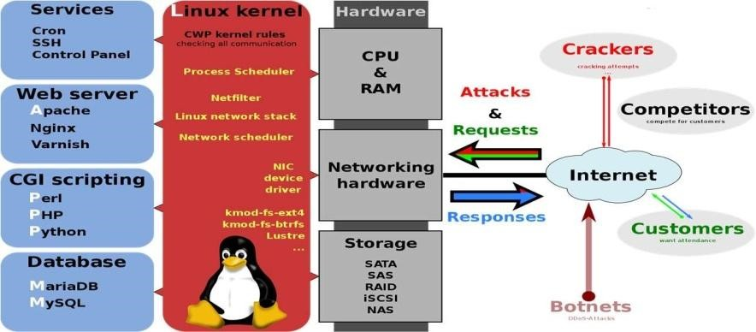

*fig5: - Technology Architecture*

### PhpMyAdmin

PhpMyAdmin is one of the most popular applications for MySQL database management. It is a free tool written in PHP. Through this software you can create, alter, drop, delete, import and export MySQL database tables. You can run MySQL queries, optimize, repair and check tables, change collation and execute other database management commands. All the Site Ground clients can manage their MySQL databases through the pre-installed phpMyAdmin software which is integrated in cPanel [8]

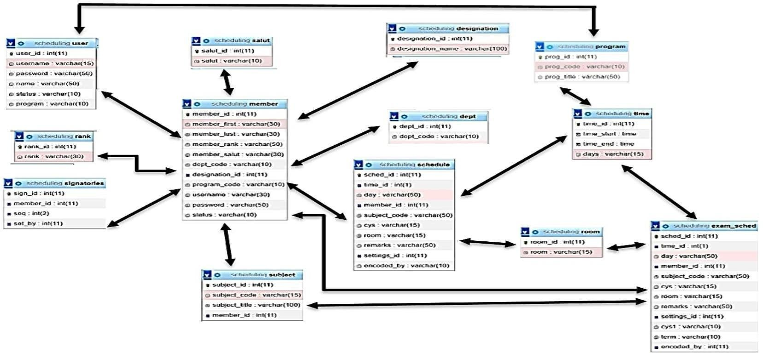

*Fig 6: - Relation Diagram*

### Database Design

ERW in the database design diagram for Schedule Vistara is shown in Figure 6. The diagram shows identified tables, their columns and relationships among tables. According to Figure 5, seven tables have been identified with their primary keys. Primary key columns set as auto increment fields which allow a unique number to be generated when a new record is inserted into a table [9]. The core table of the database is “Subject”. This tracks information about particular equipment and each field holds a single piece of information about the equipment

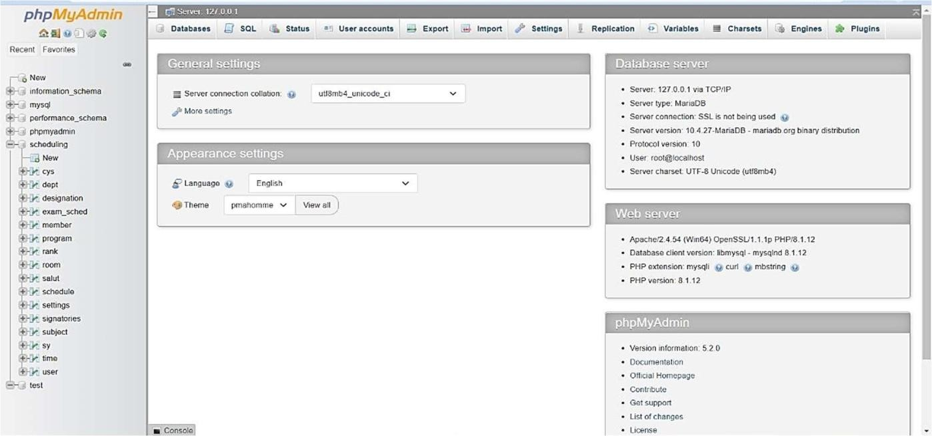

*Fig 7: - PhpMyAdmin Page*

### System Structure

The research aimed at the design of a set of anthropomorphic class scheduling systems which emphasizes the teacher’s personal expectations. Each Agent represents a teacher to create an environment. Every data must be categorized in the database together with its correct format and data types as well as a start to three schedule input, process, and output [9]. See figure 5.

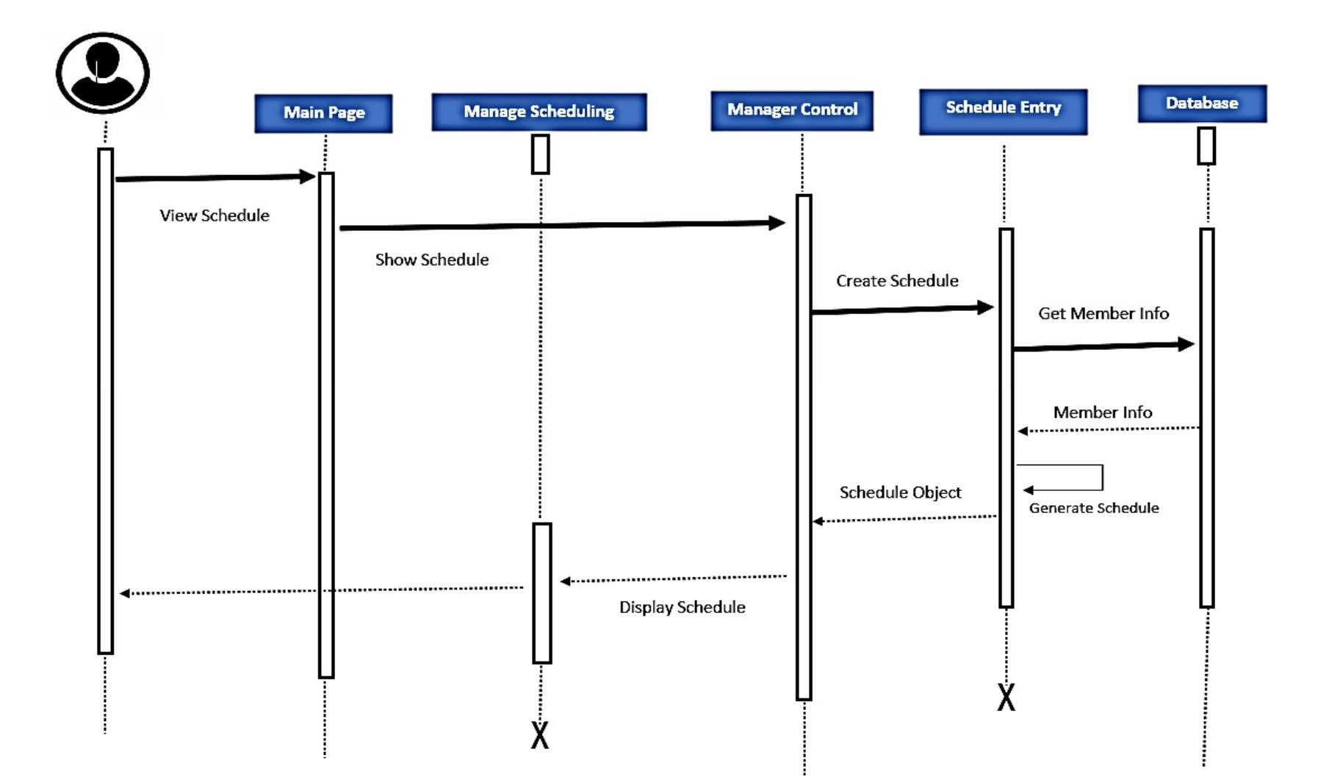

*Fig : Sequence Diagram*

# SYSTEM IMPLEMENTATION AND VALIDATION

## Design Schedule Vistara (CSS) The design for the CSS database was created based on the problem statement and the issue which the requester asked. The aims and objectives of this database is solved in the best manner by using the web application program and web server. Actually, the system is implemented to use the online format of arranging and managing the courses in order to calculate the derived data items within the database. CSS is providing the database for three different cementers, weekly courses which is divided to two categories: MWF and TTH within the period times, instructor information and class information, and etc. There are a lot of popular database software packages available in the market. The most important point is the selection of the best one to design the flexible and scalable one.

And it's very important to use very common interfaces and user-friendly programs. Here I am doing this project by using My SQL and PHP to design the perfect database with good features I mentioned in the previous section. This system is built up by writing codes, coding is the main part of the project. I am going to send all source codes and executable files by separate parts and submit them in schoology.

**Implementing database:**

## Implementation is the process of writing source code for a system. The objective is to transform the design into program and code modules. The final deliverables of the implementation phase are source code and related documents. This part of this

The paper details the implementation process of “Schedule Vistara", “Class table” application and database scripts (scripts, stored procedures and views). Further it describes the different technologies, methods and patterns used during CSS development. Implementation of CSS project needs some steps before running the project, here I explained in some steps:

## Open (XAMPP Control Panel) program then click on the “start” under actions for both (Apache & MySQL) buttons to run the server [10]. As shown in figure 8.

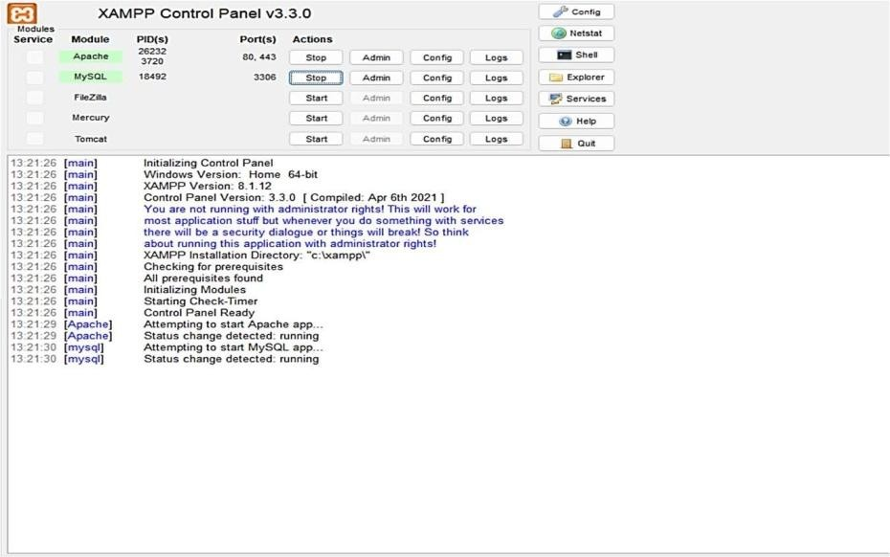

*Fig 8: - Xampp Control Panel*

## In the same window, click on the admin button to activate the phpMyAdmin interface to work on the web server as shown in figure 9.

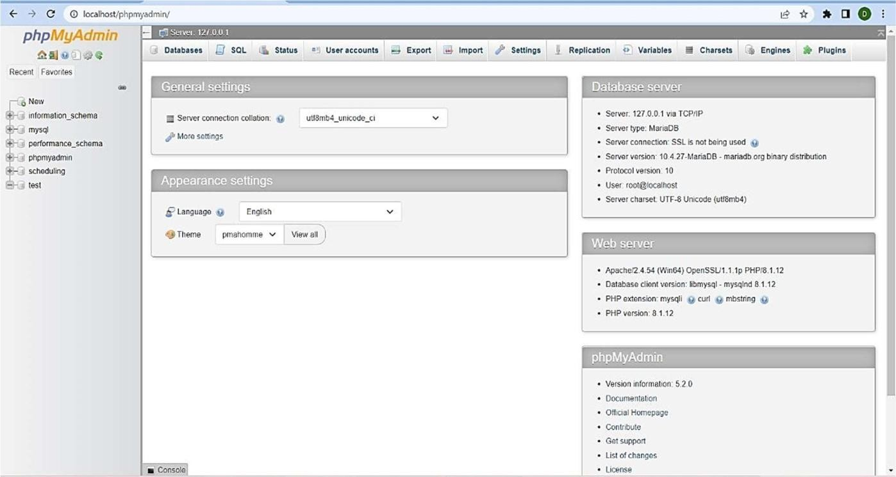

*Fig 9 :- php MyAdmin Interface*

## Import the created database by creating a new database, then click on import finally create to add a CSS database into this program, as shown in figure 10.

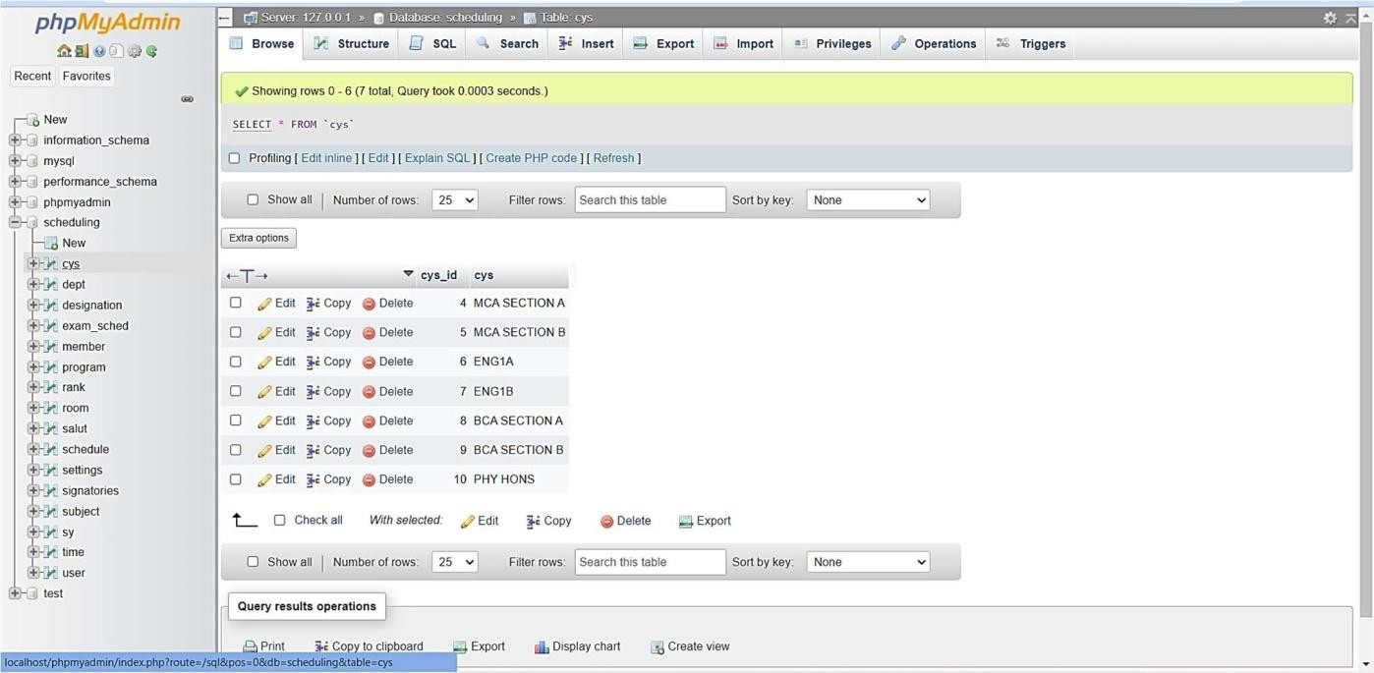

*fig 10: - Importing CSS database*

1. We can go to any internet browsing application such as to open and run our database, by writing “localhost/scheduling”. Click on Admin part to access the CSS database.

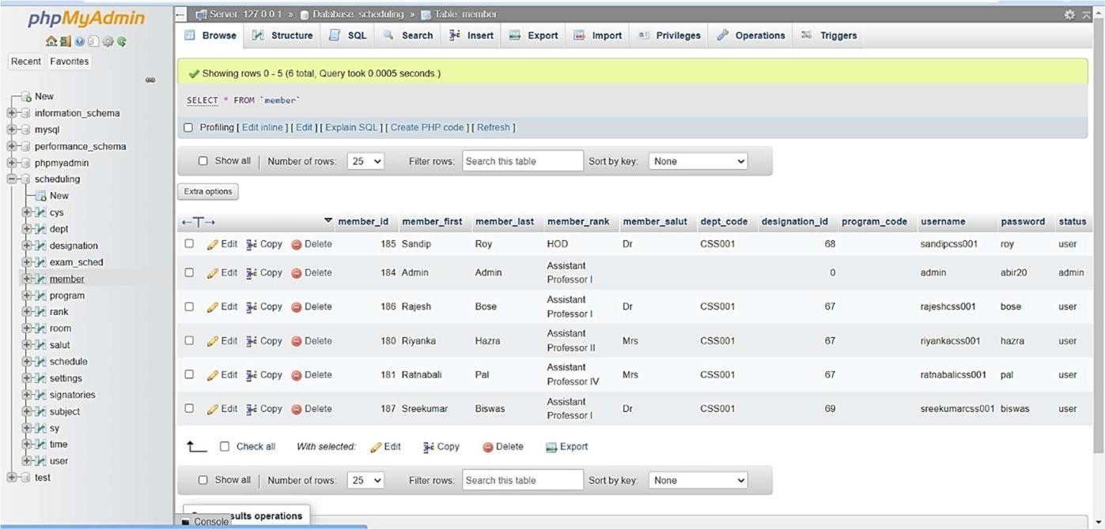

*Fig 11: - member table Database Interface*

Now we can access Class Schedule database System, the first part is “User Registration” The system check the user that who want to login to the system, if the user is not created and approved by Administrator is not allow to enter the database. We have three user types to access this system with different privileges in this project

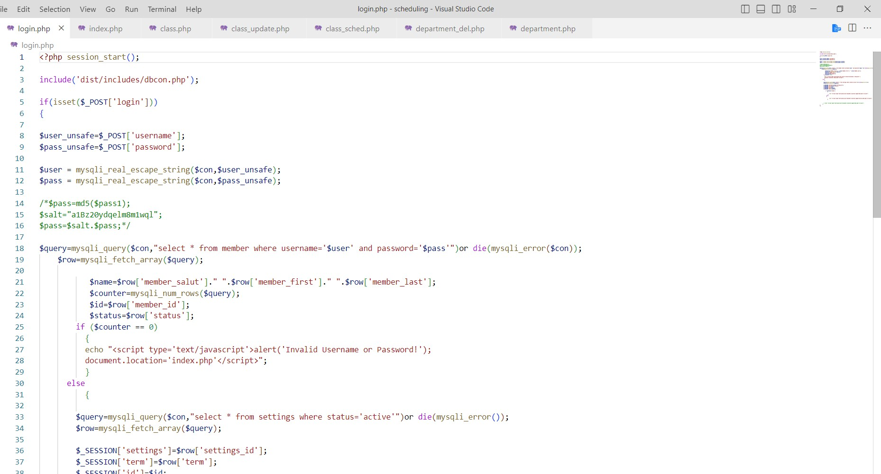

*Fig 12[i]:- Represent of login page*

## I focused on the first two users, for Student is not required. As Ms. Shrabani Sutradhar is assigned to make the admin have all levels of authority for this system, by using “admin” in both username & password parts, as shown in figure 12.

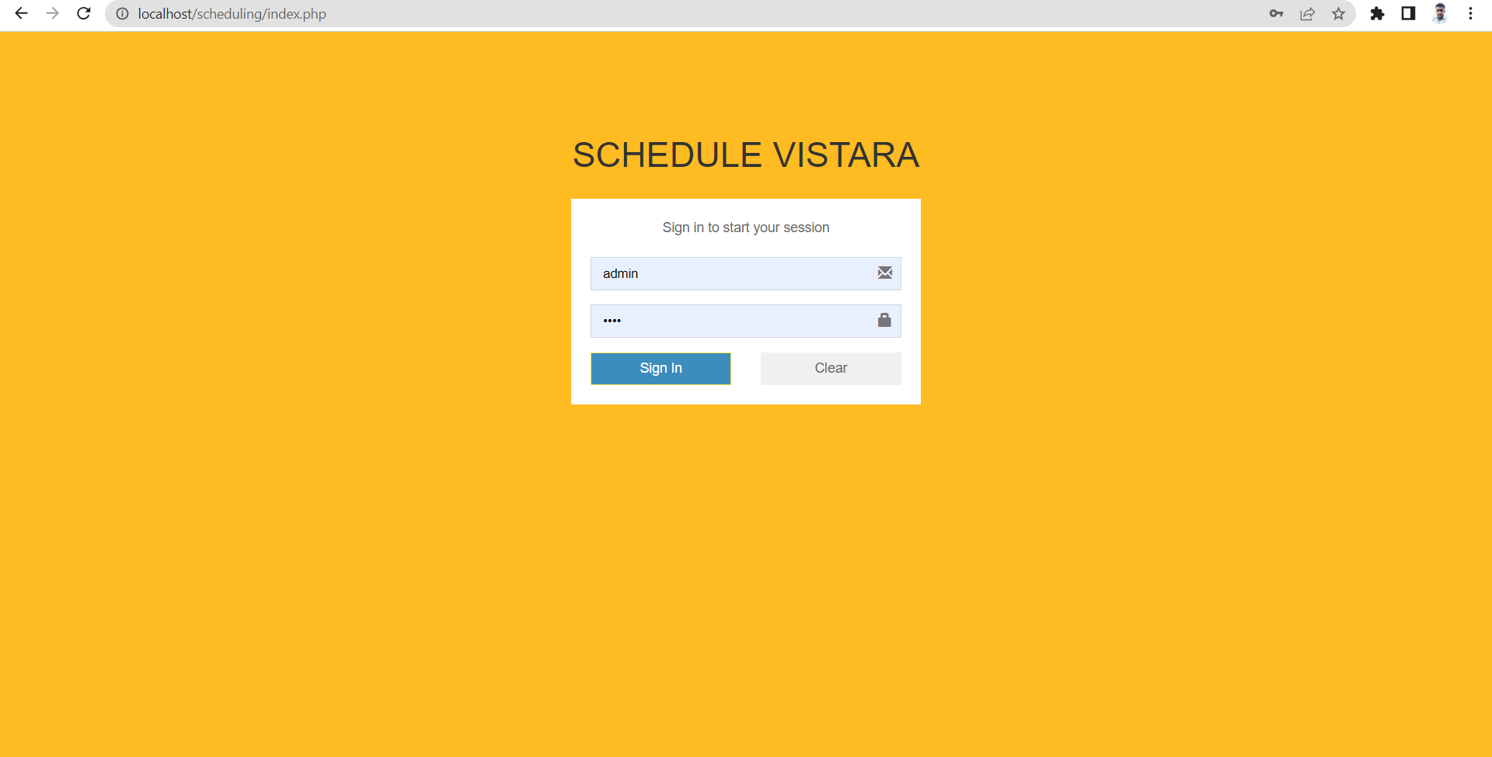

*Fig 12: - Login Page*

## By putting the correct username and password you can enter the database system to see the dashboard as shown in figure 11. In this part “Add New User” we can add other people and let them use the system by creating users for Admin, Instructor and Students, we can select the authority level in field user type.

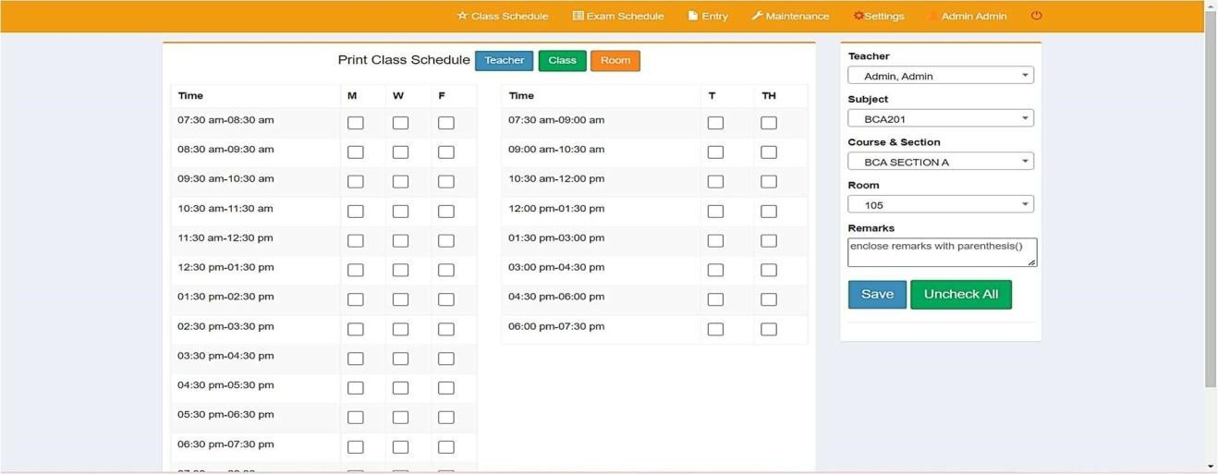

*Fig 13: - Schedule Vistara Creating Page*

## Then we can go to the “User List” to see how many users we have in the system and make the update for changing the authority and delete any account. As shown in figure 12.

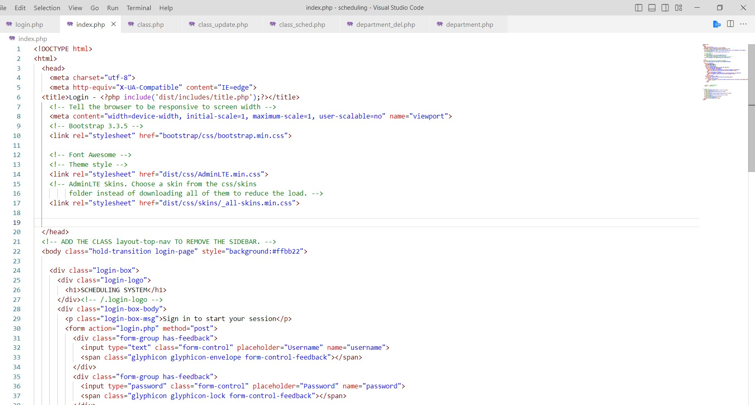

*Fig 13[i]:- Index coding page*

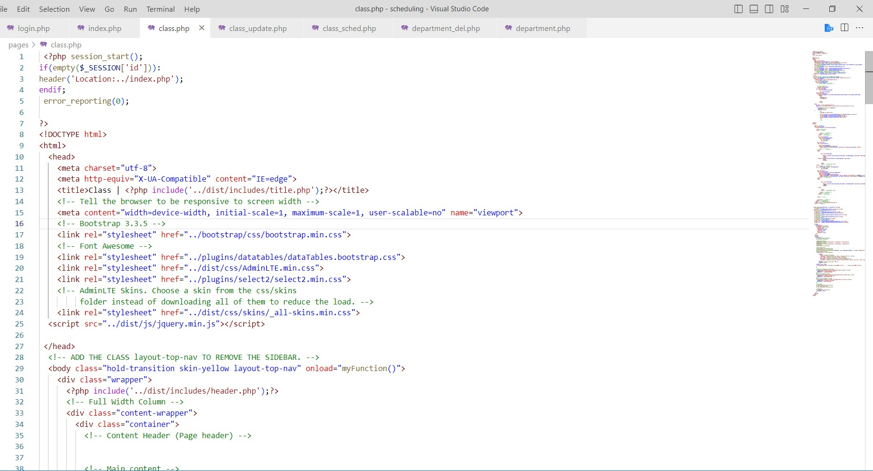

*Fig 15[i]:- Represent of fig15 coding page of classes*

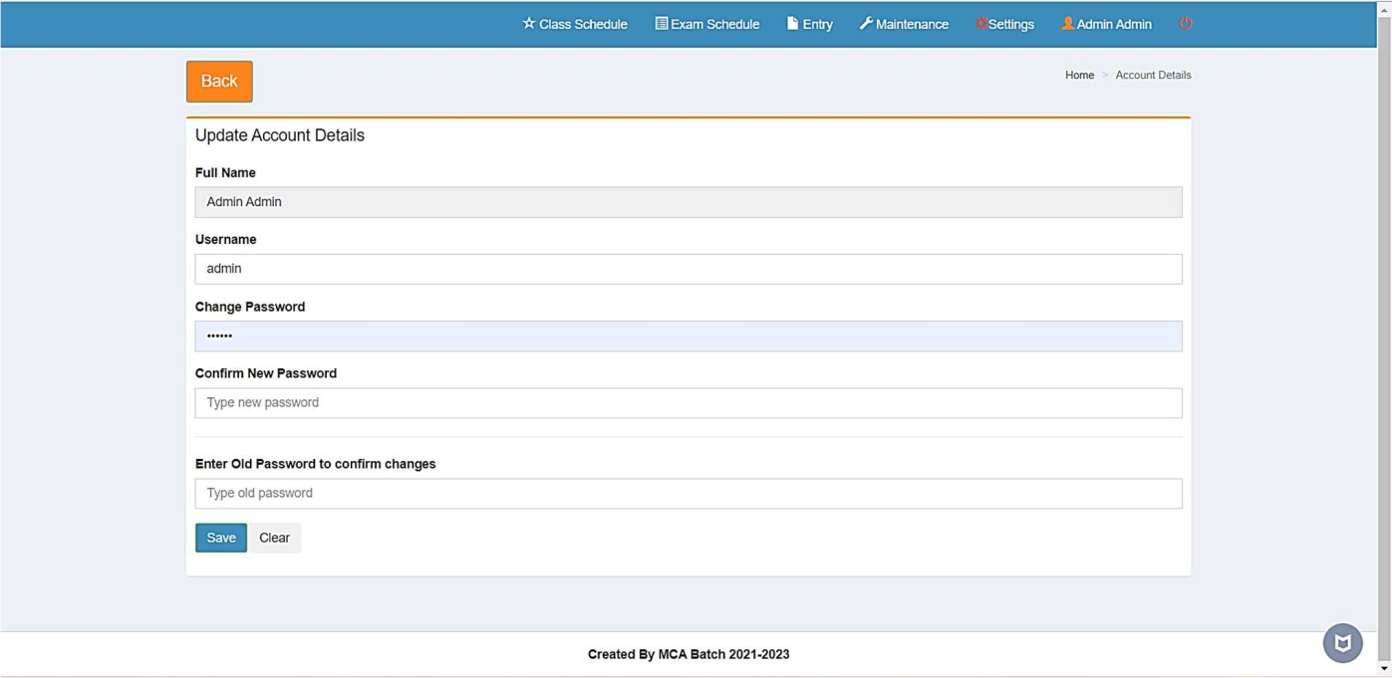

*Fig 14: - Admin Page*

## CSS has the same concept for other departments like (Department Option, Hall Option and University Year Option), we can add any new requirements and see any report that is requested by the admin.

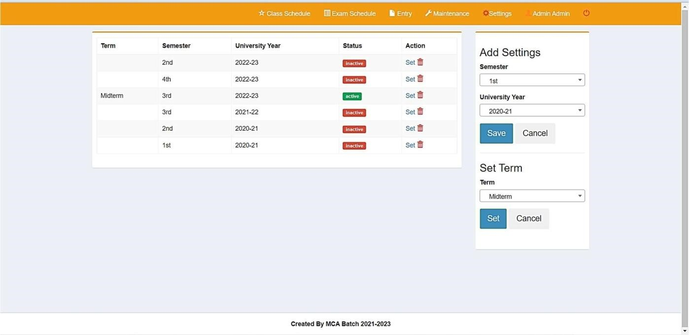

*Fig 15: - Year Wise Active Semester*

* 1. Class Schedule Option

This is the most important part of the Schedule Vistara; Class Option schema being connected with all tables to retrieve all data from other tables. Admin can add any course or subject to this system by filling all required fields as shown in figure 16. By clicking on the save button the new course was added. If the admin sees and exports the course details, he/she can go to the Class list to find all information regarding class information.

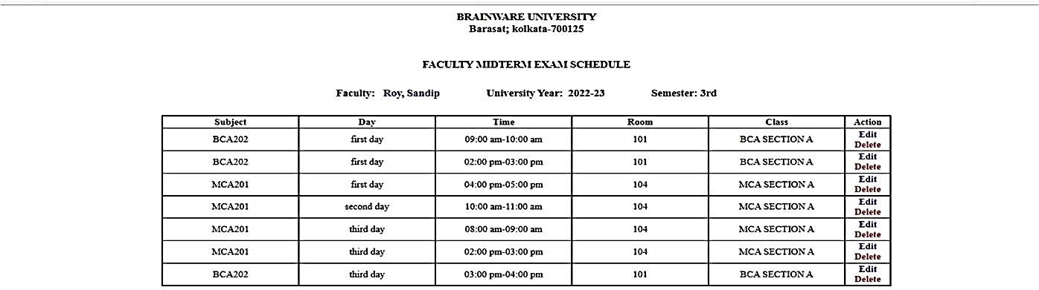

*Fig 16: - Faculty Wise Exam Schedule*

All data and information can be updated or deleted by click on the right side of the list. I skimmed the (Semester Option and Instructor Option), I am going to the last and most important part which is the Report summary for Schedule Vistara.

### Report part:

This part will be used for understanding the number of courses, class name, code, credit, Periods, Instructor name, department information, hall number and semester, as shown on figure 15. Administrators can download the detailed report of the Schedule Vistara and export it with the selected file.

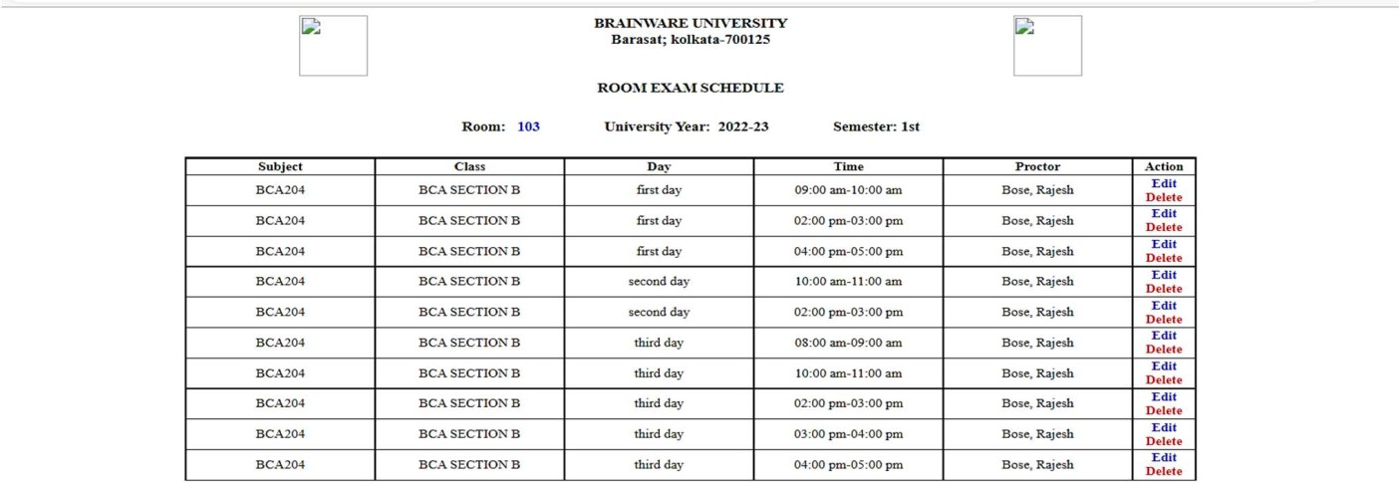

* 1. CONCLUSION AND FUTURE WORK

Database can be described as a database or a data store. A database could be an expansive amount of recorded advanced data. It can be searched, referenced, compared, changed or controlled with a minimum time and cost.

Class Scheduling System is a software that improves these processes. The system has features that can provide a database for storing records and information. It allows the end-user to add, edit, delete, save and update records or information if some changes occur. It can generate reports for example class schedule, class list, instructors list, hall list, department list and school year with different semesters.

The system demonstrated here provides a complete solution to the Schedule Vistara problem. It contains an attractive, intuitive user interface along with a user that can be used in a variety of tasks in shape or form for a fully automated solution. In this paper a Schedule Vistara is designed and developed as a web database application system by PHP language with MySQL database management system. Finally, it takes a few minutes to come up with a complete high-quality solution for assigning a significant improvement over manual work.

The most effective point for this system is that it has flexibility and scalability which is very important for the future. You can do more development on it. For future work the Schedule Vistara is needed to develop a backup option, also it would be great if it is changed to online by reserving host and domain because it has good database infrastructure, since MySQL is for a web-based database program.

The Schedule Vistara needs some future work and correlations. Design and implementation of smartphone applications remained as a future work. Users can access the application anytime and anywhere with a smartphone application, even though they don’t have access to desktop applications.

# REFERENCES

* 1. Ajax: the definitive guide anthony t. Holdener
  2. Connolly, r. (2015). Fundamentals of web development. Pearson education.
  3. Dsystem concepts by avi silberschatz, henry f. Korth, s. Sudarshan
  4. Hrle, n., martin, d., mohan, c., sarin, s. K., spyker, j. D., & yao, y. (2018). U.s. Patent application no. 15/820,468.
  5. Html, css, bootstrap, javascript and jquery web designing (web development)
  6. Html, javascript, dhtml, and php by ivan bayross
  7. Krogh, j. W., & okuno, m. (2017). Pro mysql ndb cluster.
  8. Learning php, MySQL & javascript with j query, css & html5 paperback-by robin Nixon (author)
  9. The modern javascript tutorial by ilya kantor.
  10. Gallo, M. A., & Odu, M. (2009). Examining the relationship between class scheduling and student achievement in college algebra.